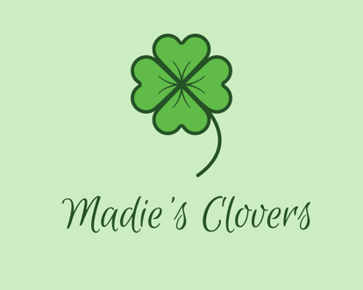
This application must be filled out in its entirety to be considered for Madie’s Clovers Scholarship. An in-person interview will be conducted in addition to this application.

Name of applicant:
Last First
Address:
Parent/Guardian information:
Last First Phone number
Fair age:

Name of School attended by applicant:
School Name County
Current GPA:

Yes No
Do you have any experience in 4H?

Areas of interest:
Yes No
Animals
Yes No
Crafts

Please list the needs you are applying for:

On a separate piece of paper please complete a 2 paragraph essay on:
Why you’d like to participate in 4H?
Why you feel like you are a good choice for this Scholarship?
What are your future 4H goals?

